2019
DenizBank A.Ş.

Card Payment Systems
DenizBank Virtual POS® - VPOS®

DenizBank Virtual POS® Application Integration Document
Distribution: October, 2012 VP. V.13.10.23 For further information on DenizBank VPOS service, please visit official website of DenizBank at: https://www. spos.denizbank.com.tr
To use DenizBank VPOS application, please visit: https://www. spos.denizbank.com.tr

Contents

Document Summary 3
1. Virtual Pos 3
1.1. The result of applying to the bank 3
1.2. Login System 3
1.3. Creating User 4
1.4. Test transaction 6
1.5. Real Transaction 6
2. 3D Transactions 6
2.1. What is 3D transaction? 6
2.2. Why is 3D transaction required? 7
2.3. What are 3d models? 7
2.3.1. 3D Pay Model 7
2.3.2. 3D Hosting Model 7
2.3.3. 3D Model 7
2.4. 3D parameters 7
3. Nonsecure Transaction 12
3.1. Nonsecure Transaction Parameters 12
3.2. NonSecure transaction return parameters: 17
4. Test Environment Details 17
4.1. User and url information for integration scripts: 17
4.2. Test Links 17
4.3. Credit Card details may be used for test 18
5. Real Environment Information 18
6. Contact Details for Virtual Pos Support Service 18
7. Additional Information 19

Document Summary
This document explains how Intertech VPOS 1.0 software, which enables the bank merchants to perform online authorization, to be integrated into the merchants’ software systems.
This version, enables the merchants to conduct online 3D (together with three submodels) and authorization transactions online.

Virtual Pos
Virtual pos is a structure enabling the merchant to conduct transactions by integrating into the Bank’s authorization system. In order to use the bank’s virtual pos system as a Merchant, you can find the details of the installation to be made after the application process is finished.

The result of applying to the bank
If the application to Denizbank has resulted positively, the bank will provide you integration documents and one user codename. Password for Backoffice entry shall be sent by sms.

Login System
By means of user code and password sms sent you by the Bank, enter to https://www.spos.denizbank.com web address. For system login, leave “shop code” blank on the following screen and enter user code in user code checkbox and password sent by sms in password checkbox. What thins can you do by using this user:
- You can assign new users. (It is explained as follows in details)
- You can view reports belong to transactions passed from all terminals of your workplace and take printouts.
- You can update user information of your assigned users and reset their passwords.
- You can authorise your assigned users in transaction basis.
- You can authorise your assigned users in screen basis.
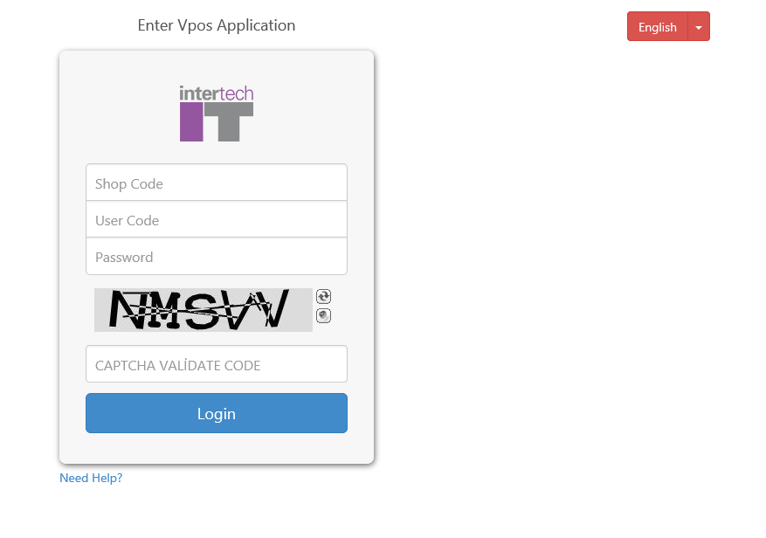
At first entry, you are directed to password change screen. Password will be updated by entering of information on the screen as follows:
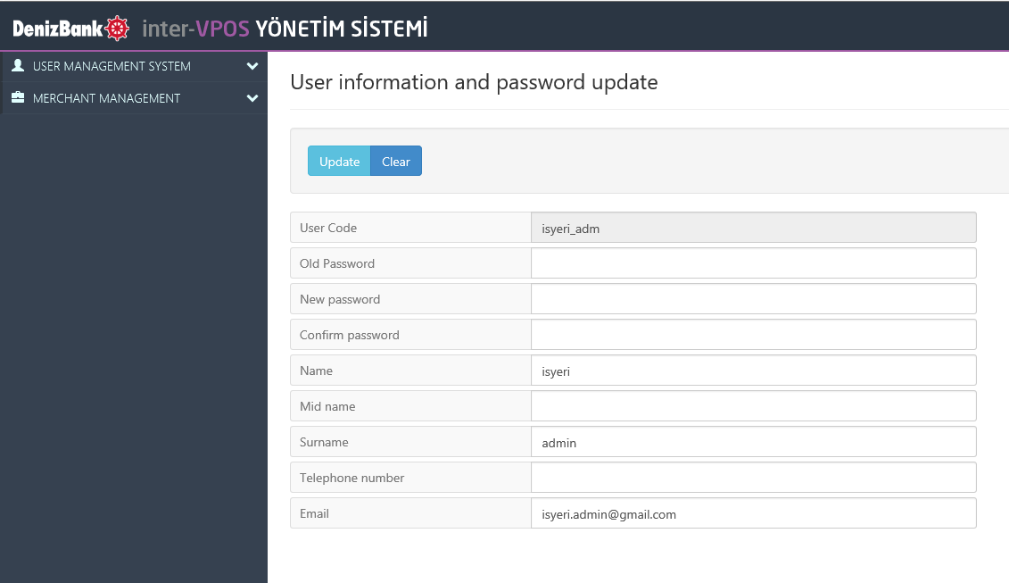

Creating User

For making a transaction on Virtual Pos, a new user must be created. A user to be given you is an admin user. Transactions can be made by the said user, are explained above in details.
There are two different user types. Screen user and online user. Online User: This is a user type used in Denizbank integration codes. Dependent on authorization with scripts, transactions such as sale, cancellation, returning, preauthorization (pre-provision), preauthorization closing etc. can be implemented. By means of this user it is not possible to visit the website or to receive report. For such aims, screen user must be created.
By means of Screen User: It is possible to visit the website. Dependent on authorization on screens, transactions such as sale, cancellation, returning, preauthorization (pre-provision), preauthorization closing etc. can be implemented. This user can not be used in integration scripts. For this aim online user must be created.
How can a screen user be created?
For screen user, “User Edit and Authorization” tab shall be clicked from “User Management System” tab which exists in left menu. Datum on screen shall be filled as follows:

Matters to be taken into consideration during User Creating:
- User’s name: In case of screen user, it is the field used during enter the website; in case of online user it is the field used in integration.
- User type: It is the value which indicates that whether the created user will be screen user or online user.
- Transaction authority profile: The field contains transaction authorities to be assigned for the user. If this field is clicked, a list will be indicated as follows. You can find explanations on authorities contained here in the Virtual Pos User Guide.

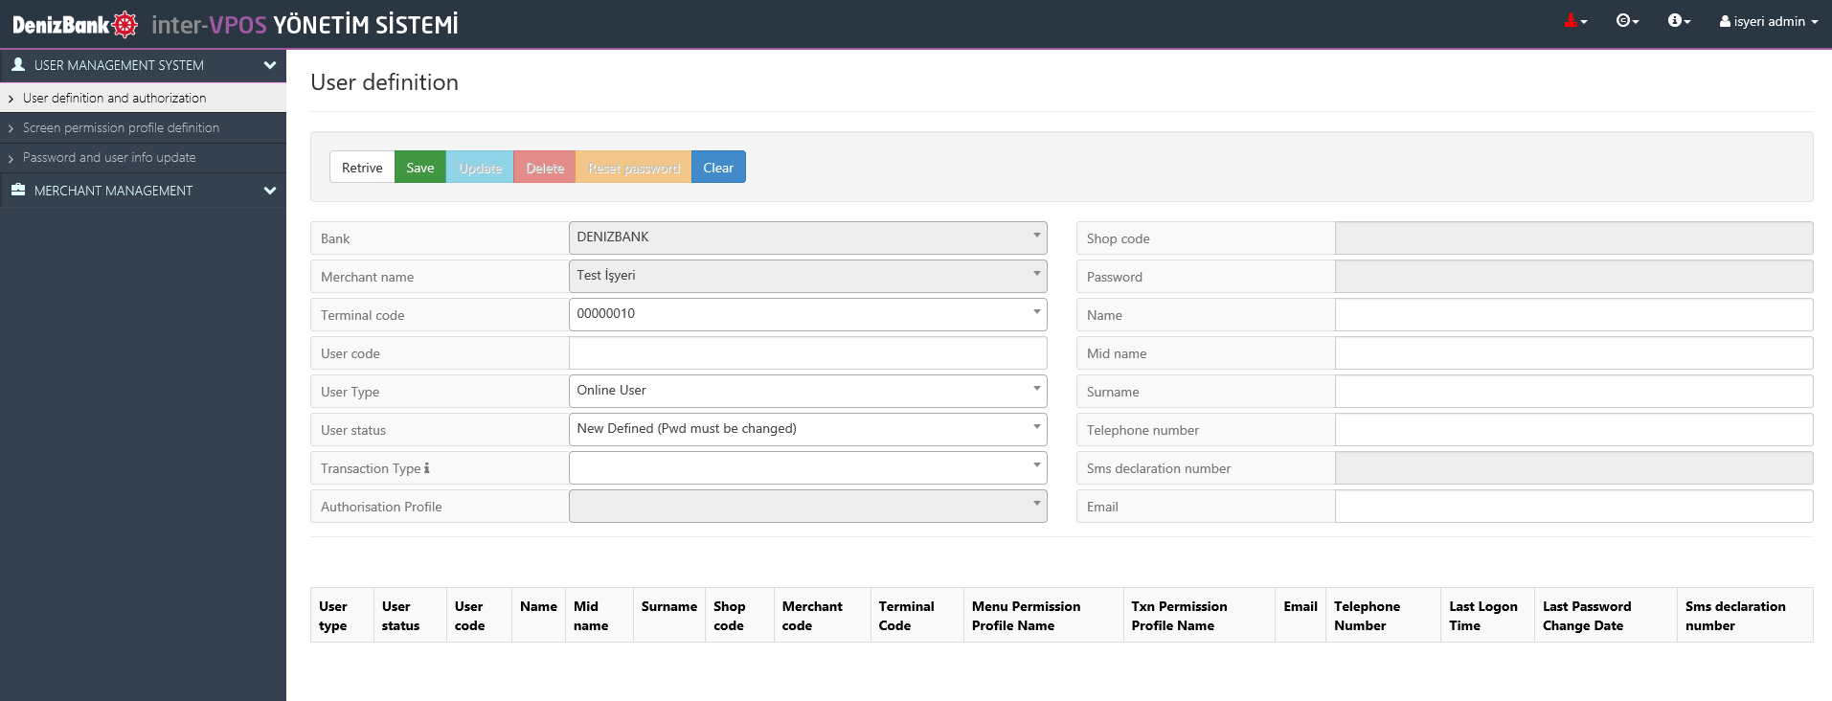

- Screen authority profile: The field contains screen authorities to be assigned for the user. If this field is clicked, a list will be indicated as follows. You can find explanations on authorities contained here in the Virtual Pos User Guide.
- You can not input datum in shop code field. After clicking save button for creating of a user, shop code info shall be displayed.
- You can not input datum in password info field. After clicking save button for creating of a user, password info shall be automatically assigned and displayed in the password info field. The password info is transiently displayed in the password field. For this reason, password info must be noted down on another place. In case the password is forgotten it can be resetted from password reset field. (This procedure is explained in the Virtual Pos User Guide in details)
- Fields of Name, Surname, second name, telephone number and e-mail address may be inputted optionally. These info are not compulsory.

Test transaction
After you have integrated your system, you will be provided with test server information, in order for you to run authorization tests. Transaction requests which you will try, are for test purposes, it’s not for conducting a real authorization transaction. Some tests may be requested to approve that you have integrated into the system. Those tests should be completed fully.

Real Transaction
After the tests have been completed successfully, you may direct your transactions to the real media server which you will obtain from your bank.

- Supported Transaction Types

- Sale
- Cancellation
- Return
- Sale on Installments
- Preauthorization (Pre-provision)

3D Transactions

What is 3D transaction?
3D transaction is a protocol which has been developed to certify that if the card belongs to the person who is conducting the transaction, and it enables the card user to enter additional information to gain control, apart from the card information itself.

Why is 3D transaction required?
To provide 3D transaction facility for secure transaction and to certify the card holder, is a method which secures the card holder and office. To conduct a 3D transaction, you must be a 3D merchant of Visa and Mastercard, Denizbank automatically provides such membership immediately after your application.

What are 3d models?

3D Pay Model
By this model it can be returned to the merchant’s system, after the 3D authentication has been carried out and then the authorization process has realized. It doesn’t require the merchant to obtain authorization again.

3D Hosting Model
If the merchant has no ssl certificate for secure transaction or if it hasn’t been accepted by the bank, or if the merchant doesn’t want to get the card details within its system, a 3D transaction is conducted on a page provided by the bank and it has been returned to the Merchant after the said transaction has realized.

3D Model
If the merchant wants to request authorization again after conducting its 3D authentication, this method can be used. It should be taken into account that there is no authorization process after the authentication. The merchant is obliged to send the returned 3D data properly during the authorization request.

3D parameters

- ShopCode : It’s the shop number provided after the virtual pos application by the bank.
- PurchAmount : It’s the amount of the transaction (cent field must be shown at most in 2 digits after the point. E.g.: 1.52).
- Currency : It’s the exchange rate information. 949 for TL.
- OrderId : It’s a number of transaction generated by the merchant. System itself generates an automatic OrderId for each transaction as well (OrderID can be sent alphanumerically at most in 36 characters).
- OkUrl : It’s the merchant’s page address to be directed by the system, when the transaction is ok (OkUrl can be sent at most in 200 characters).
- FailUrl : It’s the merchant’s page address to be directed by the system, when the transaction failed (FailUrl can be sent at most in 200 characters).
- Hash : It’s a parameter generated by obtaining the hash value through combining some values via the merchant’s password. You will find in the example document how it has been generated. It is used for checking the accuracy of the information sent by the system.
- Rnd : It’s a value generated at random, at each request. It’s used for hash authentication.
- TxnType : It’s a transaction type. “Auth” should be sent for authorization.
- InstallmentCount : It means the number of installments. If a transaction is an installment transaction, that number should be higher than 1. If a value smaller than 1 is sent or a value which is nonnumeric is sent, it shall be deemed as 0.
- SecureType : It can be 3DPay, 3DModel, 3DHost or NonSecure. It means the method you want to conduct the transaction. This transaction should be 3DPay.
- CardType : It represents the card type. 0 should be sent for Visa, and 1 for Mastercard.
- Pan : It’s the card number.
- Cvv2 : It’s a number in 3 or 4 digits in on reverse side of the card.
- Expiry : It is sent in the form of MonthMonthYearYear (E.g.: 0215 for February 2015). It indicates the expiry date of the card.
- BonusAmount : It shows the amount of bonus wanted to be used by the card holder for the transaction.
Sale
In the example script below, an aspx payment page example for 3D payment flow is given. Payment scripts in other languages and flows shall be sent together with related documents..

<%@ Page Language="C#" %>
<!DOCTYPE html PUBLIC "-//W3C//DTD XHTML 1.0 Transitional//EN" "http://www.w3.org/TR/xhtml1/DTD/xhtml1-transitional.dtd">
<html xmlns="http://www.w3.org/1999/xhtml">
<head id="Head1" runat="server">
<title>3D Pay</title>
</head>
<body>
<%
String shopCode = "3123";
String purchaseAmount = "1.00"; //İşlem tutarı
String currency = "949"; // Kur Bilgisi - 949 TL
String orderId = ""; //Sipariş Numarası
String okUrl = "http://93.94.199.122:7000/odemesayfasi3dpay.aspx";
String failUrl = "http://93.94.199.122:7000/odemesayfasi3dpay.aspx";
String rnd = DateTime.Now.ToString();
String installmentCount = "";
String txnType = "Auth";
String merchantPass = "gDg1N";
String str = shopCode + orderId + purchaseAmount + okUrl + failUrl + txnType + installmentCount + rnd + merchantPass;
System.Security.Cryptography.SHA1 sha = new System.Security.Cryptography.SHA1CryptoServiceProvider();
byte[] bytes = System.Text.Encoding.GetEncoding("ISO-8859-9").GetBytes(str);
byte[] hashingbytes = sha.ComputeHash(bytes);
String hash = Convert.ToBase64String(hashingbytes);
%>
<center>
<form method="post" action="https://sanaltest.denizbank.com/MPI/Default.aspx">
<input type="hidden" name="Lang" value="tr" />
<input type="hidden" name="SecureType" value="3DPay" />
<input type="hidden" name="InstallmentCount" value="<%=installmentCount %>" />
<input type="hidden" name="TxnType" value="<%=txnType %>" />
<input type="hidden" name="Hash" value="<%=hash %>" />
<input type="hidden" name="Rnd" value="<%=rnd%>" />
<input type="hidden" name="FailUrl" value="<%=failUrl%>" />
<table>
<tr><td>Kredi Kart Numarası:</td>
<td><input type="text" name="Pan" size="20" value="" /></td>
</tr>
<tr><td>Güvenlik Kodu:</td>
<td><input type="text" name="Cvv2" size="4" value="" /></td>
</tr>
<tr> <td>Son Kullanma Tarihi (MMYY):</td>
<td><input type="text" name="Expiry" value="" /></td>
</tr>
<tr><td>Bonus:</td>
<td><input type="text" name="BonusAmount" value="" /></td>
</tr>
<tr> <td>Visa/MC secimi:</td>
<td><select name="CardType">
<option value="0">Visa</option><option value="1">MasterCard</option>
</select></td>
</tr>
<tr> <td align="center" colspan="2"><input type="submit" value="Tamam"/></td> </tr>
</table>
<input type="hidden" name="ShopCode" value="<%=shopCode%>" />
<input type="hidden" name="PurchAmount" value="<%=purchaseAmount%>" />
<input type="hidden" name="Currency" value="<%=currency%>" />
<input type="hidden" name="OrderId" value="<%=orderId%>" />
<input type="hidden" name="OkUrl" value="<%=okUrl%>" />
</form>
</center>
</body>
</html>

3D status values and meanings

-1 | Payment authentication failed
-2 | Error in pares message
-3 | Pares message authentication failed
1 | Authentication is Ok
2 | Error in Veres message
3 | Issuer or merchant not registered in the system
4 | Issuer or merchant not registered in the system
5 | Payment authentication failed
6 | Authentication attempt made

ECI Values
ECI |  | Authentication Status | Explanation | Description
Visa | Master Card | Authentication Status | Explanation | Description
05 | 02 | Y | Ok | Success
06 | 01 | A | Authentication failed but an authentication attempt made | Authentication could not be performed, but authentication attempt provided
07 | 01 | U | Authentication failed, a technical problem or error occured | Authentication could not be performed, there exists a technical error or other problem
- | - | N | Authentication failed | Authentication failed
- | - | E | Authentication attempt made | Error during the authentication process
3D MODEL
The same values as in the 3D Pay model are obtained. But, to indicate that the transaction is 3DModel, the SecureType value of the transaction should be 3DModel.
3D Host Model
- ShopCode : It’s the shop number provided after the virtual pos application by the bank.
- PurchAmount : It’s the amount of the transaction (cent field must be shown at most in 2 digits after the point. E.g.: 1.52).
- Currency : It’s the exchange rate information. 949 for TL.
- OrderId : It’s a number of transaction generated by the merchant. System itself generates an automatic OrderId for each transaction as well (OrderID can be sent alphanumerically at most in 36 characters).
- OkUrl : It’s the merchant’s page address to be directed by the system, when the transaction is ok (OkUrl can be sent at most in 200 characters).
- FailUrl : It’s the merchant’s page address to be directed by the system, when the transaction failed (FailUrl can be sent at most in 200 characters).
- Hash : It’s a parameter generated by obtaining the hash value through combining some values via the merchant’s password. You will find in the example document how it has been generated. It s used for checking the accuracy of the information sent by the system.
- Rnd : It’s a value generated at random, at each request. It’s used for hash authentication.
- TxnType : It’s a transaction type. Auth should be sent for authorization.
- InstallmentCount : It means the number of installments. If a transaction is an installment transaction, that number should be higher than 1. If a value smaller than 1 is sent or a value which is nonnumeric is sent, it shall be deemed as 0.
- SecureType : It should be 3DHost for this transaction.

3D Return Values

- HASHPARAMS :. It includes the parameter names used for calculating the returned hash
- HASHPARAMSVAL: It includes the parameter values within the returned hash value. The merchant should generate a hash value which is the same as with the one used when sending a request by adding the merchant password to those values.
- HASH : It’s the hash value generated by the server. The merchant should compare this value and its own generated value. If the values aren’t consistent with each other, a security problem may be the case. So, it should be applied to the bank and information should be provided.
- Version : It represents the version of 3D protocol.
- MerchantID : It’s the merchant’s register ID in Visa/Mastercard index servers.
- ShopCode : It’s the merchant’s shop number.
- TxnStat : It represents the result of 3D message transaction.
- 3Dstatus : It’s the case occured for authorization, as a result of 3D protocol. Values may be between -1 and 6. No authorization is made, for the cases when it is smaller than 1.
- RetCode : It’s the code of error received as a result of the transaction.
- RetDet : It’s the explanation of error received as a result of the transaction.
- Eci : The value specifying the result of the transaction generated in 3D authentication.
- PayerAuthenticationCode : Value of 3D CAVV
- PayerTxnId : It’s the 3D transaction ID.
- CavvAlg : It’s an algorithm used for calculating Cavv.
- PAResVerified : It shows if the Pares message has been verified or not.
- PAResSyntaxOK :It shows if the syntax of Pares message is correct or not.
- OrderId : It’s the OrderId generated by the server.
- PurchAmount : It’s the amount of the transaction.
- Exponent : It’s the number of digits used in decimal point
- Description : Explanation sent for the transaction
- Currency : Exchange rate information. (949 for TL)
- OkUrl : OkUrl information sent for the transaction
- FailUrl : FailUrl information sent for the transaction
- ErrorMessage : Error message
- TransId : Authorization transaction id, if an authorization transaction realized
- ProcReturnCode : It’s the code returned by the authorization system.
- HostRefNum: Host Reference number
- AuthCode: Authentication Code of authorization.
- TxnResult : It represents the result of authorization transaction. Success- means Ok, Failed : means Unsuccessfull
- ErrorMessage : It includes the explanation, if any error occured in authorization.

3D status values and meanigs

-1 | Payment authentication failed
-2 | Error in pares message
-3 | Pares message authentication failed
1 | Authentication is Ok
2 | Error in Veres message
3 | Issuer or merchant not registered in the system
4 | Issuer or merchant not registered in the system
5 | Payment authentication failed
6 | Authentication attempt made

Nonsecure Transaction
It’s the process of obtaining authorization without using 3D payment protocol
Link to be used for testing: http://93.94.199.122:7000/DenizNonSecure.aspx

3.1. Nonsecure Transaction Parameters
- ShopCode : It’s the shop number provided after the virtual pos application by the bank.
- UserCode : User code for authorization system. (It’s obtained from the bank)
- UserPass : User password for authorization system. (It’s obtained from the bank)
- PurchAmount : It’s the amount of the transaction (cent field must be shown at most in 2 digits after the point. E.g.: 1.52).
- Currency : It’s the exchange rate information. 949 for TL.
- OrderId : It’s a number of transaction generated by the merchant. System itself generates an automatic OrderId for each transaction as well (OrderID can be sent alphanumerically at most in 36 characters).
- TxnType: It’s a transaction type. Auth should be sent for authorization.
- InstallmentCount: It means the number of installments. If a transaction is an installment transaction, that number should be higher than 1. If a value smaller than 1 is sent or a value which is nonnumeric is sent, it shall be deemed as 0.
- SecureType: It can be 3DPay, 3DModel, 3DHost or NonSecure. It means the method you want to conduct the transaction. This transaction should be 3DPay.
- CardType: It represents the card type. 0 should be sent for Visa, and 1 for Mastercard.
- Pan : It’s the card number.
- Cvv2: It’s a number in 3 or 4 digits on reverse side of the card.
- Expiry: It is sent in the form of MonthMonthYearYear (E.g.: 0215 for February 2015). It indicates the expiry date of the card.
- BonusAmount: It shows the amount of bonus wanted to be used by the card holder for the transaction.
- Lang: User language. It should be TR for Turkish.
- MOTO: If the transaction is desired to be saved as authorization in moto type, this value should be set as 1. If it’s not set or a value different from 1 is given, the authorization will try to save as Ecommerce.

If an authorization is tried to be obtained after the 3D authentication, the following parametres returning from the 3D transaction should be sent as well.
- PayerAuthenticationCode: 3D authentication code (CAVV)
- Eci: 3D Eci value
- PayerTxnId: 3D transaction id

Example script code for Nonsecure transaction is below:

Example code for .Net is as follows. Example codes for cancellation and return transactions shall be sent as script.

<%@ Page Language="C#" %>
<!DOCTYPE HTML PUBLIC "-//W3C//DTD HTML 4.0 Transitional//EN" >
<title>Non Secure Payment</title>
</head>
<body>
<%
if(Request.Form.Count>0){
/*Moto-ecommerce işlem için gerekli alanlar gönderim için listeye ekleniyor.*/
String format = "{0}={1}&";
StringBuilder sb = new StringBuilder();
sb.AppendFormat(format, "ShopCode", Request.Form["ShopCode"]);
sb.AppendFormat(format, "PurchAmount", Request.Form["Amount"]);
sb.AppendFormat(format, "Currency", Request.Form["Currency"]);
sb.AppendFormat(format, "OrderId", Request.Form["OrderId"]);
sb.AppendFormat(format, "InstallmentCount", Request.Form["InstallmentCount"]);
sb.AppendFormat(format, "TxnType", Request.Form["TxnType"]);
sb.AppendFormat(format, "orgOrderId", Request.Form["orgOrderId"]);
sb.AppendFormat(format, "UserCode", Request.Form["UserCode"]);
sb.AppendFormat(format, "UserPass", Request.Form["UserPass"]);
sb.AppendFormat(format, "SecureType", "NonSecure");
sb.AppendFormat(format, "Pan", Request.Form["Pan"]);
sb.AppendFormat(format, "Expiry", Request.Form["Expiry"]);
sb.AppendFormat(format, "Cvv2", Request.Form["Cvv2"]);
sb.AppendFormat(format, "BonusAmount", Request.Form["BonusAmount"]);
sb.AppendFormat(format, "CardType", Request.Form["CardType"]);
sb.AppendFormat(format, "Lang", "TR");
sb.AppendFormat(format, "MOTO", Request.Form["MOTO"]);
//sb.AppendFormat(format, "PayerAuthenticationCode", Request.Form["PayerAuthenticationCode"]);
//sb.AppendFormat(format, "Eci", Request.Form["Eci"]);
//sb.AppendFormat(format, "PayerTxnId", Request.Form["PayerTxnId"]);
try
{
System.Net.HttpWebRequest request = (System.Net.HttpWebRequest)System.Net.WebRequest.Create("https://sanaltest.denizbank.com/MPI/Default.aspx");
byte[] parameters = System.Text.Encoding.GetEncoding("ISO-8859-9").GetBytes(sb.ToString());
request.Method = "POST";
request.ContentType = "application/x-www-form-urlencoded";
request.ContentLength = parameters.Length;
System.IO.Stream requeststream = request.GetRequestStream();
requeststream.Write(parameters, 0, parameters.Length);
requeststream.Close();
Response.Write(sb.ToString());
System.Net.HttpWebResponse resp = (System.Net.HttpWebResponse)request.GetResponse();
System.IO.StreamReader responsereader = new System.IO.StreamReader(resp.GetResponseStream(), System.Text.Encoding.GetEncoding("ISO-8859-9"));
String responseStr = responsereader.ReadToEnd();

if(responseStr!=null)
{
string[] paramArr = responseStr.Split(';', ';');
%>
<table>
<%
foreach(string p in paramArr){
string[] nameValue = p.Split('=');
%>
<tr><td>
<%
Response.Write(nameValue[0]);
%>
</td><td>
<% if(nameValue.Length>1) Response.Write(nameValue[1]);%>
</td></tr>
<%
}
%>
</table>
<%
}
}
catch(Exception ex)
{
Response.Write("Hata " + ex.Message +" " + ex.StackTrace + (ex.InnerException!=null ? ex.InnerException.Message : ""));
}
}
%>
<center>
<form method="post">
<table>
<tr>
<td>Kredi Kart Numarası:</td>
<td><input type="text" name="Pan" size="20" value=""/>
</tr>
<tr>
<td>Güvenlik Kodu:</td>
<td><input type="text" name="Cvv2" size="4" value=""/></td>
</tr>
<tr>
<td>Son Kullanma Tarihi (MMYY):</td>
<td><input type="text" name="Expiry" value=""/></td>
</tr>
<tr>
<td>Tutar:</td>
<td><input type="text" name="Amount" value="1.01"/></td>
</tr>
<tr>
<td>Kur secimi</td>
<td><select name="Currency">
<option value="949">TL</option>
<option value="840">USD</option>
<option value="978">EUR</option>
<option value="826">BPB</option>
</select>
</td>
</tr>
<tr>
<td>Bonus:</td>
<td><input type="text" name="BonusAmount" value=""/></td>
</tr>
<tr>
<td>Taksit Sayısı:</td>
<td><input type="text" name="InstallmentCount" value=""/></td>
</tr>
<tr>
<td>Visa/MC secimi</td>
<td>
<select name="CardType">
<option value="0">Visa</option>
<option value="1">MasterCard</option>
<option value="3">Amex</option>
</select>
</td>
</tr>
<tr>
<td>Order No</td>
<td><input type="text" name="OrderId" value=""/></td>
</tr>
<tr>
<td>İşlem Tipi</td>
<td>
<select name="TxnType">
<option value="Auth" selected="selected">Auth</option>
<option value="PreAuth">PreAuth</option>
<option value="PostAuth">PostAuth</option>
<option value="Refund">Refund</option>
<option value="Void">Void</option>
<option value="StatusHistory">StatusHistory</option>
</select>
</td>
</tr>
<tr>
<td>Orijinal İşlem Order No</td>
<td><input type="text" name="OrgOrderId" value=""/></td>
</tr>
<tr>
<td>Shop Code</td>
<td><input type="text" name="ShopCode" size="20" value="12345"/>
</tr>
<tr>
<td>Kullanıcı Kodu</td>
<td><input type="text" name="UserCode" size="20" value="vpos1"/>
</tr>
<tr>
<td>Kullanıcı Şifre</td>
<td><input type="text" name="UserPass" size="20" value="1"/></td>
</tr>
<tr>
<td>MOTO (1-MOTO, 0 veya "" - Ecommerce)</td>
<td><input type="text" name="MOTO" size="20" value="0"/></td>
</tr>
<tr>
<td align="center" colspan="2">
<input type="submit" value="Ödemeyi Tamamla"/>
</td>
</tr>
</table>
</form>
</center>
</body>
</html>

3.2. NonSecure transaction return parameters:

- TransId : It is authorization transaction id, if authorization transaction is realized.
- ProcReturnCode : It’s the code returned by the Authorization system.
- HostRefNum : Host Reference number
- AuthCode : Authentication Code of authorization.
- TxnResult : It represents the result of authorization transaction. Success- means Ok, Failed : means Unsuccessfull
- ErrorMessage : It includes the explanation, if any error occured in authorization.

Test Environment Details

User and url information for integration scripts:
Shop Code : 3123
User Code : InterTestApi
Password : 3
3D Pass : gDg1N

Test Links

Test link for 3D transaction (3dpay-3dmodel)
https://sanaltest.denizbank.com/mpi/Default.aspx

Test link to be used for Non-secure transaction
https://sanaltest.denizbank.com/mpi/Default.aspx

Test link for 3D Host model
http://sanaltest.denizbank.com/mpi/3DHost.aspx

User and url information for Website:
URL : https://sanaltest.denizbank.com
ShopCode : 3123
UserCode : InterTest1
Password : InterTest1

Credit Card details may be used for test

Test Card Details | expiration date | cvv2
4090700214269159 | 0117 | 494
5453010000095414 | 0117 | 991
503396199900034153 | 0117 | 514
5453010000095786 | 0117 | 781

3D verification password for test cards: 123

Real Environment Information

Address to be posted:
If 3DHost method is being used:
“https://spos.denizbank.com/mpi/3DHost.aspx

If NonSecure, 3Dpay and 3Dmodel methods are being used :
“https://spos.denizbank.com/mpi/Default.aspx” is defined within script.

Contact Details for Virtual Pos Support Service
If any problem is experienced about virtual pos service, the support service can be reached from the following mail address and phone number. (In the event of any problem, the values you have posted for information and integration should be shared.)

E-mail : sanalpos@denizbank.com – sanalpos@intertech.com.tr

Phone : 0 ( 212 ) 370 66 00 – 0 212 348 87 97 - 0 212 348 87 98
Out of Office hours: + 90 (212) 348 87 88(7/2
Response Codes (Error Explanations)
Response Code | Explanations
00 | TR:=Onaylandi;;EN:=Approved
01 | TR:=Bankanizi Arayin;;EN:=Call your Bank
02 | TR:=Bankanizi Arayin (Ozel);;EN:=Call your Bank (Special)
03 | TR:=Gecersiz Uye Isyeri;;EN:=Invalid Merchant
04 | TR:=Kart'a El Koy;;EN:=Seize the Card
05 | TR:=Onaylanmadi;;EN:=Unapproved
06 | TR:=Stop List Bildirim Hatasi;;EN:=Stop List Reporting Error
07 | TR:=Kart'a El Koy (Ozel);;EN:=Seize the Card (Special)
08 | TR:=Kimlik Sorgula;;EN:=Query the Identity
09 | TR:=Tekrar Deneyin;;EN:=Try Again
11 | TR:=Onaylandi (VIP);;EN:= Approved (VIP)
12 | TR:=Geçersiz Islem;;EN:=Invalid Transaction
13 | TR:=Geçersiz Tutar;;EN:=Invalid Amount
14 | TR:=Geçersiz Hesap Numarasi;;EN:= Invalid Account Number
15 | TR:=Tanimsiz Issuer;;EN:= Undefined Issuer
25 | TR:=Kayit Dosyada Bulunamadi;;EN:=Record Not Found in the File
28 | TR:=Orjinal Reddedildi;;EN:=Original Rejected
29 | TR:=Orjinal Bulunmadi;;EN:=Original Not found
30 | TR:=Mesaj Hatasi;;EN:=Message Error
33 | TR:=Süresi Dolmus Kart, El Koy;;EN:=Expired Card, Seize the Card
36 | TR:=Kisitli Kart, El Koy;;EN:=Limited Card Seize the Card
38 | TR:=PIN Deneme Sayisi Asti;;EN:=PIN Tries Exceeded
41 | TR:=Kayip Kart, Karti Alin;;EN:= Lost Card, Receive the Card
43 | TR:=Çalinti Kart, Karti Alin;;EN:= Stolen Card, Receive the Card
51 | TR:=Limit Yetersiz;;EN:=Insufficient Limit
52 | TR:=Tanimli Hesap Yok;;EN:=No Defined Account
53 | TR:=Tanimli Hesap Yok;;EN:= No Defined Account
54 | TR:=Süresi Dolmus Kart;;EN:=Expired Card
55 | TR:=Yanlis PIN;;EN:=Wrong PIN
57 | TR:=Karta Izin Verilmeyen Islem;;EN:=Unauthorized Card Transaction
58 | TR:=POSa Izin Verilmeyen Islem;;EN:=Unauthorized POS Transaction
61 | TR:=Para Çekme Limiti Asildi;;EN:=Withdrawal Limit Exceeded
62 | TR:=Sinirli Kart;;EN:= Limited Card
63 | TR:=Güvenlik Ihlali;;EN:=Security Breach
65 | TR:=Para Cekme Limiti asildi;;EN:= Withdrawal Limit Exceeded
75 | TR:=PIN Deneme Limiti asildi;;EN:=PIN Trying Limit Exceeded
76 | TR:=Key Senkronizasyon Hatasi;;EN:=Key Synchronization Error
77 | TR:=Red, Script Yok;;EN:=Rejection, No Script
78 | TR:=Güvenli Olmayan PIN;;EN:=Nonsecure PIN
79 | TR:=ARQC hatasi;;EN:=ARQC error
81 | TR:=Aygit Versiyon Uyusmazligi;;EN:=Device Version Mismatch
85 | TR:=Onaylandi;;EN:= Approved
91 | TR:=Issuer calismiyor;;EN:=Issuer not working
92 | TR:=Finansal Kurum Taninmiyor;;EN:=Unknown Financial Institution
95 | TR:=POS Günsonu Hatasi;;EN:=POS End of Day Error
96 | TR:=SİSTEM HATASI;;EN:=SYSTEM ERROR

Additional Information

Copyright Notice DenizBank Virtual POS® - Inter-VPOS® - Inter-POS® All rights reserved.

Whilst every effort has been made to ensure that the information in this document is accurate, DenizBank does not accept any liability for any errors, omissions, or losses resulting from any party’s actions or avoiding-negligence in taking due actions, either natural or legal. The information in this document may be changed at any time without being obliged to give notice to any party.

Without written permission of DenizBank A.Ş, no part of this document may be distributed, copied and transferred in any form by electronic or mechanical means or by any other means and methods. This document may be changed without any further notice. All brand names and product names mentioned in this document are registered trademarks.

